IFET COLLEGE OF ENGINEERING
[An Autonomous Institution]
LAB MANUAL


DEPARTMENT OF ARTIFICIAL INTELLIGENCE AND DATA SCIENCE
IFETCE R-2023

SUBJECT CODE : 23AD5L01
SUBJECT NAME : BIG DATA ENGINEERING LABORATORY
YEAR/SEM : III / V

Prepared by: | Approved by:
Mrs.S.ARUNAKUMARI  AP/AI&DS | Mrs.P.MANJUBALA,  HOD/AI&DS

DEPARTMENT OF ARTIFICIAL INTELLIGENCE AND
DATA SCIENCE
DEPARTMENT VISION
To accomplish eminence to have global recognition through education, innovation, and collaborative research in the realm of Data Science.

DEPARTMENT MISSION
- To develop essential competencies in the fields of Artificial Intelligence and Data Science.
- To instigate research skills and contribute towards innovation by applying the latest cutting-edge technology in data science.
- To promote lifelong learning and motivate entrepreneurial skills among students.

PROGRAMME OUTCOMES (PO)
- On the completion of the program the graduates are expected to know or develop the abilities defined through the Program Outcomes.
- The Program Outcomes of Artificial Intelligence and Data Science program is given below.

PO1. Apply the knowledge of mathematics, science, engineering fundamentals, and an engineering specialization to the solution of complex engineering problems.

PO2. Identify, formulate, research literature, and analyse complex engineering problems reaching substantiated conclusions using first principles of mathematics, natural sciences, and engineering sciences.

PO3. Design solutions for complex engineering problems and design system components or processes that meet the specified needs with appropriate consideration for the public health and safety, and the cultural, societal, and environmental considerations.

PO4. Use research-based knowledge and research methods including design of experiments, analysis and interpretation of data, and synthesis of the information to provide valid conclusions.

PO5. Create, select, and apply appropriate techniques, resources, and modern engineering and IT tools including prediction and modelling to complex engineering activities with an understanding of the limitations.

PO6. Apply reasoning informed by the contextual knowledge to assess societal, health, safety, legal and cultural issues and the consequent responsibilities relevant to the professional engineering practice.

PO7. Understand the impact of the professional engineering solutions in societal and environmental contexts, and demonstrate the knowledge of, and need for sustainable development.

PO8. Apply ethical principles and commit to professional ethics and responsibilities and norms of the engineering practice.

PO9. Function effectively as an individual, and as a member or leader in diverse teams, and in multidisciplinary settings.

PO10. Communicate effectively on complex engineering activities with the engineering community and with society at large, such as, being able to comprehend and write effective reports and design documentation, make effective presentations, and give clear instructions.

PO11. Demonstrate knowledge and understanding of the engineering and management principles and apply these to one’s own work, as a member and leader in a team, to manage projects and in multidisciplinary environments.

PO12. Recognize the need for, and have the preparation and ability to engage in independent and life-long learning in the broadest context of technological change.

PROGRAMME SPECIFIC OUTCOMES
(PSO)
On completion of B.Tech. Artificial Intelligence and Data Science programme, graduates will be able to:

PSO 1 Understand, analyse and develop essential proficiency in the areas related to data science and artificial intelligence in terms of underlying statistical and computational principles and apply the knowledge to solve practical problems.

PSO 2 Implement Artificial Intelligence and data science techniques such as search algorithms, neural networks, machine learning and data analytics for solving a problem and designing novel algorithms for successful career and entrepreneurship.

PSO 3 Apply the theoretical and practical aspects of Data Science to manage and solve complex societal problems.

SEMESTER-III

23AD5L01 | Big Data Engineering Laboratory | Category: Professional Core Courses
23AD5L01 | Big Data Engineering Laboratory | L | T | P | C
23AD5L01 | Big Data Engineering Laboratory | - | - | 3 | 1.5

PRE-REQUISITES:
- Database Management Systems

COURSE OBJECTIVES

The faculty will enhance the skills of the students to
- Formulate predictive and classification models using regression, SVM, and decision trees in R.
- Build clustering and MapReduce-based solutions for analyzing large datasets.
- Explore weather data analysis and NoSQL modeling for scalable big data processing.
- Familiarize with Hadoop ecosystem tools and perform data analysis using HiveQL.
- Obtain hands-on experience with MongoDB integration and data visualization tools

COURSE OUTCOMES:

After successful completion of this course, students will able to
CO1: Demonstrate regression, classification, and clustering in R for big data analysis. CO2: Apply MapReduce and Apache Spark for efficient big data processing.
CO3: Analyse MapReduce and NoSQL models to perform scalable analysis.
CO4: Evaluate big data techniques using Hive, Pig, and Apache Kafka.
CO5: Design data visualizations using Matplotlib and Seaborn. CO – PO - PSO MAPPING:
POs & PSOs  COs | PROGRAMME OUTCOMES (PO) |  |  |  |  |  |  |  |  |  |  |  | PSO
POs & PSOs  COs | PO1 | PO2 | PO3 | PO4 | PO5 | PO6 | PO7 | PO8 | PO9 | PO10 | PO11 | PO12 | PSO1 | PSO2 | PSO3
CO1 | 3 | 2 | 2 | 1 | 2 | - | 1 | 1 | 1 | 2 | 2 | 2 | 2 | 3 | 1
CO2 | 3 | 2 | 2 | 1 | 2 | - | - | 1 | 2 | 2 | 2 | 2 | 2 | 3 | 1
CO3 | 3 | 3 | 2 | 2 | 2 | - | - | 1 | 2 | 2 | 2 | 2 | 3 | 3 | 2
CO4 | 3 | 3 | 3 | 2 | 2 | - | 1 | 2 | 2 | 3 | 2 | 3 | 3 | 3 | 2
CO5 | 3 | 3 | 3 |  | 2 | - |  | 1 | 2 | 2 | 2 | 3 | 3 | 3 | 3
BDE Lab | 3 | 3 | 2 | 2 | 2 |  | 1 | 1 | 2 | 2 | 2 | 2 | 3 | 3 | 2

LIST OF EXPERIMENTS

  - Implement word count / frequency programs using MapReduce.
  - Develop a MapReduce Program to Analyse a Weather Dataset.
  - Implement Sharding and Replication Concepts Using MongoDB.
  - Query a NoSQL Key-Value Database (e.g., Redis or MongoDB) for Fast Data Retrieval.
  - Install, Configure, and Run Hadoop and HDFS in Pseudo-Distributed Mode.
  - Perform Data Ingestion and Filtering Using Apache Pig.
  - Create Tables in Apache Hive and Perform Data Analysis Using HiveQL.
  - Execute HiveQL Queries with Joins, Subqueries, Views, and Indexing.
  - Build an Animated Line Chart Using Plotly.
  - Create basic visualizations like line charts, bar charts, and pie charts using sample datasets and data visualization tools such as Matplotlib / Seaborn.
  - Implementation of Linear Regression, SVM, and Decision Tree Models on Iris Dataset Using R.
  - Setup and Execution of a Big Data Analytics Project Using Apache Spark with PySpark in Python.

Contact Periods:
Lecture: Periods Tutorial: Periods Practical: 45 Periods Project: Periods

TOTAL: 45 PERIODS

Software Requirements:
Hadoop, R Studio, Hive, Pig, Apache Spark, NoSQL, Mongo DB, Python- Numpy, Scipy, Matplotlib, Pandas, seaborn.

INDEX

SI.NO | TOPICS | PAGE.NO
 | Implement word count / frequency programs using MapReduce. | 8
 | Develop a MapReduce Program to Analyse a Weather Dataset. | 12
 | Implement Sharding and Replication Concepts Using MongoDB. | 15
 | Query a NoSQL Key-Value Database (e.g., Redis or MongoDB) for Fast Data Retrieval. | 18
 | Install, Configure, and Run Hadoop and HDFS in Pseudo-Distributed Mode. | 20
6 | Perform Data Ingestion and Filtering Using Apache Pig. | 22
7 | Create Tables in Apache Hive and Perform Data Analysis Using HiveQL. | 24
8 | Execute HiveQL Queries with Joins, Subqueries, Views, and Indexing. | 26
9 | Build an Animated Line Chart Using Plotly. | 29
10 | Create basic visualizations like line charts, bar charts, and pie charts using sample datasets and data visualization tools such as Matplotlib / Seaborn. | 31
CONTENT BEYOND SYLLABUS
11 | Implementation of Linear Regression, SVM, and Decision Tree Models on Iris Dataset Using R | 34
12 | Setup and Execution of a Big Data Analytics Project Using Apache Spark with PySpark in Python | 37

Ex No: 1 | Implement word count / frequency programs using MapReduce.
Date : | Implement word count / frequency programs using MapReduce.

AIM:
To implement a Word Count program using the MapReduce programming model on Hadoop framework to count the frequency of each word in a text file.

ALGORITHM:
Mapper Phase:
- Read line-by-line from the input split.
- Tokenize each line into words.
- For each word, emit (word, 1).
Reducer Phase:
- Collect all values associated with the same key (word).
- Sum up the values for each key.
- Emit (word, total_count).
Directory & File Structure:
WordCountProject/
├── input/
│ └── file.txt
├── classes/
├── WordCount.java
├── wordcount.jar

PROGRAM:
File: WordCount.java
import java.io.IOException;
import java.util.StringTokenizer;
import org.apache.hadoop.conf.Configuration;
import org.apache.hadoop.fs.Path;
import org.apache.hadoop.io.IntWritable;
import org.apache.hadoop.io.Text;
import org.apache.hadoop.mapreduce.Job;
import org.apache.hadoop.mapreduce.Mapper;
import org.apache.hadoop.mapreduce.Reducer;
import org.apache.hadoop.mapreduce.lib.input.FileInputFormat;
import org.apache.hadoop.mapreduce.lib.output.FileOutputFormat;
public class WordCount {
public static class TokenizerMapper extends Mapper<Object, Text, Text, IntWritable> {
private final static IntWritable one = new IntWritable(1);
private Text word = new Text();
public void map(Object key, Text value, Context context) throws IOException, InterruptedException {
StringTokenizer itr = new StringTokenizer(value.toString());
while (itr.hasMoreTokens()) {
word.set(itr.nextToken());
context.write(word, one);
}
}
}
public static class IntSumReducer extends Reducer<Text, IntWritable, Text, IntWritable> {
private IntWritable result = new IntWritable();
public void reduce(Text key, Iterable<IntWritable> values, Context context) throws IOException, InterruptedException {
int sum = 0;
for (IntWritable val : values) {
sum += val.get();
}
result.set(sum);
context.write(key, result);
}
}
public static void main(String[] args) throws Exception {
Configuration conf = new Configuration();
Job job = Job.getInstance(conf, "word count");
job.setJarByClass(WordCount.class);
job.setMapperClass(TokenizerMapper.class);
job.setCombinerClass(IntSumReducer.class);
job.setReducerClass(IntSumReducer.class);
job.setOutputKeyClass(Text.class);
job.setOutputValueClass(IntWritable.class);
FileInputFormat.addInputPath(job, new Path(args[0]));
FileOutputFormat.setOutputPath(job, new Path(args[1]));
System.exit(job.waitForCompletion(true) ? 0 : 1);
}
}

Linux & Hadoop Commands to Compile and Run:
# Compile Java
javac -classpath `hadoop classpath` -d classes WordCount.java
# Create JAR
jar -cvf wordcount.jar -C classes/ .
# Create input
mkdir input
echo "hello world hello hadoop mapreduce hadoop world" > input/file.txt
# Upload input to HDFS
hdfs dfs -mkdir /wordinput
hdfs dfs -put input/file.txt /wordinput
# Run Hadoop job
hadoop jar wordcount.jar WordCount /wordinput /wordoutput
# View output
hdfs dfs -cat /wordoutput/part-r-00000

Sample Input (file.txt):
hello world hello hadoop mapreduce hadoop world

OUTPUT:
hadoop 2
hello 2
mapreduce 1
world 2

RESULT:
The Word Count program was successfully implemented using MapReduce. The program accurately counted and returned the frequency of each word from the input file.

On completion of the above program the following PO’s and PSO’s are attained
CO | MAPPING WITH PROGRAMME OUTCOMES |  |  |  |  |  |  |  |  |  |  |  | PSO’S
CO | PO1 | PO2 | PO3 | PO4 | PO5 | PO6 | PO7 | PO8 | PO9 | PO10 | PO11 | PO12 | PSO1 | PSO2 | PSO3
CL301.2 | 3 | 2 | 2 | 1 | 2 | - | - | 1 | 2 | 2 | 2 | 2 | 2 | 3 | 1

Ex No: 2 | Develop a MapReduce Program to Analyse a Weather Dataset.
Date : | Develop a MapReduce Program to Analyse a Weather Dataset.
AIM:
To implement a Word Count program using the MapReduce programming model on Hadoop framework to count the frequency of each word in a text file.

ALGORITHM:
Mapper Phase:
- Read each line of the weather dataset.
- Extract the year and temperature from the line (usually fixed-width format or CSV).
- Emit key-value pairs as (year, temperature).
Reducer Phase:
- Group all temperatures by the year.
- Find the maximum temperature for each year.
- Emit (year, max_temperature).
Directory & File Structure:
WeatherAnalysisProject/
├── input/
│ └── weather.txt
├── classes/
├── WeatherAnalysis.java
├── weatheranalysis.jar

PROGRAM:
File: WeatherAnalysis.java
import java.io.IOException;
import org.apache.hadoop.conf.Configuration;
import org.apache.hadoop.fs.Path;
import org.apache.hadoop.io.IntWritable;
import org.apache.hadoop.io.Text;
import org.apache.hadoop.mapreduce.Job;
import org.apache.hadoop.mapreduce.Mapper;
import org.apache.hadoop.mapreduce.Reducer;
import org.apache.hadoop.mapreduce.lib.input.FileInputFormat;
import org.apache.hadoop.mapreduce.lib.output.FileOutputFormat;
public class WeatherAnalysis {
public static class TempMapper extends Mapper<Object, Text, Text, IntWritable> {
private Text year = new Text();
private IntWritable temperature = new IntWritable();
public void map(Object key, Text value, Context context) throws IOException, InterruptedException {
String line = value.toString();
// Assuming format: YYYYMMDD...<other>...TEMP
String yearStr = line.substring(0, 4);
String tempStr = line.substring(14, 18).trim(); // Example: temp at position 15–18
try {
int temp = Integer.parseInt(tempStr);
year.set(yearStr);
temperature.set(temp);
context.write(year, temperature);
} catch (NumberFormatException e) {
// Ignore corrupt/missing temperature lines
}
}
}
public static class MaxTempReducer extends Reducer<Text, IntWritable, Text, IntWritable> {
private IntWritable result = new IntWritable();
public void reduce(Text key, Iterable<IntWritable> values, Context context) throws IOException, InterruptedException {
int maxTemp = Integer.MIN_VALUE;
for (IntWritable val : values) {
maxTemp = Math.max(maxTemp, val.get());
}
result.set(maxTemp);
context.write(key, result);
}
}
public static void main(String[] args) throws Exception {
Configuration conf = new Configuration();
Job job = Job.getInstance(conf, "weather analysis");
job.setJarByClass(WeatherAnalysis.class);
job.setMapperClass(TempMapper.class);
job.setReducerClass(MaxTempReducer.class);
job.setOutputKeyClass(Text.class);
job.setOutputValueClass(IntWritable.class);
FileInputFormat.addInputPath(job, new Path(args[0]));
FileOutputFormat.setOutputPath(job, new Path(args[1]));
System.exit(job.waitForCompletion(true) ? 0 : 1);
}
}
Linux & Hadoop Commands to Compile and Run:
javac -classpath `hadoop classpath` -d classes WeatherAnalysis.java
jar -cvf weatheranalysis.jar -C classes/ .
hdfs dfs -mkdir /weatherinput
hdfs dfs -put input/weather.txt /weatherinput
hadoop jar weatheranalysis.jar WeatherAnalysis /weatherinput /weatheroutput
hdfs dfs -cat /weatheroutput/part-r-00000
Sample Input (weather.txt)
202001011234567891020
202001021234567891015
202101011234567891030
202101021234567891027
OUTPUT:
2020 20
2021 30

RESULT:
The MapReduce program successfully analyzed the weather dataset and displayed the maximum temperature recorded for each year.
On completion of the above program the following PO’s and PSO’s are attained
CO | MAPPING WITH PROGRAMME OUTCOMES |  |  |  |  |  |  |  |  |  |  |  | PSO’S
CO | PO1 | PO2 | PO3 | PO4 | PO5 | PO6 | PO7 | PO8 | PO9 | PO10 | PO11 | PO12 | PSO1 | PSO2 | PSO3
CL301.2 | 3 | 3 | 2 | 2 | 2 | - | - | 1 | 2 | 2 | 2 | 2 | 3 | 3 | 2

Ex No: 3 | Implement Sharding and Replication Concepts Using MongoDB.
Date : | Implement Sharding and Replication Concepts Using MongoDB.
AIM:
To understand and implement the concepts of sharding and replication in MongoDB for efficient and scalable data storage and availability.

ALGORITHM:
For Replication (Replica Set):
- Start multiple MongoDB instances as replica set members (3 recommended).
- Initiate the replica set with one primary and two secondary nodes.
- Insert sample data into the primary node.
- Verify that the secondary nodes sync data from the primary.
- Test failover by shutting down the primary and checking automatic election.
For Sharding:
- Start multiple mongod instances as shards.
- Start mongos as the router.
- Start a config server (mongod --configsvr).
- Connect to mongos using the mongo shell.
- Enable sharding for a database and shard a collection using a shard key.
- Insert data and observe automatic distribution across shards.
Directory & File Structure:
MongoShardingReplication/
├── rs1/
│ └── db/
├── rs2/
│ └── db/
├── rs3/
│ └── db/
├── config/
│ └── db/
├── shard1/
│ └── db/
├── shard2/
│ └── db/
├── start_replica.sh
├── start_shard.sh
└── mongo_insert_test.js
Linux Shell Script Examples:
File: start_replica.sh (for Replication):
#!/bin/bash
mongod --replSet "rs0" --port 27017 --dbpath ./rs1/db --bind_ip localhost --fork --logpath ./rs1/mongo.log
mongod --replSet "rs0" --port 27018 --dbpath ./rs2/db --bind_ip localhost --fork --logpath ./rs2/mongo.log
mongod --replSet "rs0" --port 27019 --dbpath ./rs3/db --bind_ip localhost --fork --logpath ./rs3/mongo.log
mongo --port 27017 <<EOF
rs.initiate({
_id: "rs0",
members: [
{ _id: 0, host: "localhost:27017" },
{ _id: 1, host: "localhost:27018" },
{ _id: 2, host: "localhost:27019" }
]
})
EOF
File: start_shard.sh (for Sharding):
#!/bin/bash
mongod --configsvr --replSet configReplSet --port 26050 --dbpath ./config/db --bind_ip localhost --fork --logpath ./config/config.log
mongod --shardsvr --port 27020 --dbpath ./shard1/db --bind_ip localhost --fork --logpath ./shard1/mongo.log
mongod --shardsvr --port 27021 --dbpath ./shard2/db --bind_ip localhost --fork --logpath ./shard2/mongo.log
mongos --configdb configReplSet/localhost:26050 --bind_ip localhost --fork --logpath mongos.log --port 27017
mongo --port 27017 <<EOF
sh.addShard("localhost:27020")
sh.addShard("localhost:27021")
sh.enableSharding("college")
sh.shardCollection("college.students", { "rollno": 1 })
EOF

Sample MongoDB JS Insertion File: mongo_insert_test.js
use college
db.students.insertMany([
{ rollno: 101, name: "Raja", mark: 95 },
{ rollno: 102, name: "Pooja", mark: 85 },
{ rollno: 103, name: "Roja", mark: 75 }
])
OUTPUT:
> sh.status()
sharding version: ...
shards:
{ "_id" : "shard0000", "host" : "localhost:27020" }
{ "_id" : "shard0001", "host" : "localhost:27021" }
> rs.status()
Set Name: rs0
Members:
[0] PRIMARY: localhost:27017
[1] SECONDARY: localhost:27018
[2] SECONDARY: localhost:27019

RESULT:
Successfully implemented MongoDB Replication using a replica set and Sharding using mongos router. Ensured data distribution and availability across multiple instances.

On completion of the above program the following PO’s and PSO’s are attained
CO | MAPPING WITH PROGRAMME OUTCOMES |  |  |  |  |  |  |  |  |  |  |  | PSO’S
CO | PO1 | PO2 | PO3 | PO4 | PO5 | PO6 | PO7 | PO8 | PO9 | PO10 | PO11 | PO12 | PSO1 | PSO2 | PSO3
CL301.2 | 3 | 3 | 2 | 2 | 2 | - | - | 1 | 2 | 2 | 2 | 2 | 3 | 3 | 2

Ex No: 4 | Query a NoSQL Key-Value Database (e.g., Redis or MongoDB) for Fast Data Retrieval.
Date :

AIM:
To efficiently query large volumes of key-value structured data using MongoDB, demonstrating its scalability and speed for big data applications.

ALGORITHM:
Start MongoDB Cluster
- Use a sharded cluster with replication for high availability and scalability.
Connect to MongoDB Shell
- Connect using mongosh or a driver in Python/Java/etc.
Create a Database & Collection
- Use database: college
- Collection: students
- Enable sharding on the college.students collection using rollno as shard key.
Insert Bulk Data
- Generate and insert thousands/millions of student records using insertMany().
Indexing for Performance
- Create indexes on fields like rollno, name for fast retrieval.
Querying
- Perform queries using .find() on indexed fields.
- Use projections to fetch only required fields.
- Use aggregation if needed for big data summarization.
Display Output
- Show sample outputs to validate successful data retrieval.
FOLDER STRUCTURE:
BigDataMongoProject/
├── mongo_bulk_insert.js # Bulk insertion script
├── mongo_query_test.js # Query and index script

PROGRAM:
File: mongo_bulk_insert.js
use college
// Enable sharding
sh.enableSharding("college")
sh.shardCollection("college.students", { rollno: 1 })
// Sample bulk insert
let bulk = []
for (let i = 1; i <= 100000; i++) {
bulk.push({ rollno: i, name: "Student_" + i, mark: Math.floor(Math.random() * 100) })
}
db.students.insertMany(bulk)
File: mongo_query_test.js
use college
// Create index
db.students.createIndex({ rollno: 1 })
// Query student by roll number
db.students.find({ rollno: 50000 })
// Project specific fields
db.students.find({}, { name: 1, mark: 1, _id: 0 }).limit(5)
Linux & Hadoop Commands to Compile and Run:
mongosh < mongo_bulk_insert.js
mongosh < mongo_query_test.js
OUTPUT:
{ "name" : "Student_50000", "mark" : 80 }
{ "name" : "Student_50001", "mark" : 81 }
...
RESULT:
The MongoDB query program successfully retrieved student records from the key-value NoSQL database, demonstrating fast and efficient data access suitable for big data applications.
On completion of the above program the following PO’s and PSO’s are attained
CO | MAPPING WITH PROGRAMME OUTCOMES |  |  |  |  |  |  |  |  |  |  |  | PSO’S
CO | PO1 | PO2 | PO3 | PO4 | PO5 | PO6 | PO7 | PO8 | PO9 | PO10 | PO11 | PO12 | PSO1 | PSO2 | PSO3
CL301.2 | 3 | 3 | 2 | 2 | 2 | - | - | 1 | 2 | 2 | 2 | 2 | 3 | 3 | 2

Ex No: 5 | Install, Configure, and Run Hadoop and HDFS in Pseudo-Distributed Mode.
Date :
Aim :

To install, configure, and run Hadoop and HDFS in Pseudo-Distributed Mode for managing big data storage and processing.

Algorithm:
- Install Java:
Ensure Java (JDK 8 or above) is installed and configured.
- Download and Extract Hadoop:
Download Hadoop from https://hadoop.apache.org/ and extract it.
- Set Environment Variables:
Add HADOOP_HOME, JAVA_HOME, and update PATH in .bashrc or .zshrc.
- Configure Hadoop XML Files:
  - core-site.xml: Set default filesystem (e.g., hdfs://localhost:9000)
  - hdfs-site.xml: Set replication factor, name and data directories.
  - mapred-site.xml: Set framework to yarn.
  - yarn-site.xml: Configure resource manager and node manager.
- Format Namenode:
Run hdfs namenode -format.
- Start Hadoop Services:
Use start-dfs.sh and start-yarn.sh.
- Verify Services:
Use jps command to check if NameNode, DataNode, ResourceManager, NodeManager are running.

FOLDER STRUCTURE:
HadoopPseudoMode/
├── hadoop-3.x.x/
│ ├── etc/hadoop/
│ │ ├── core-site.xml
│ │ ├── hdfs-site.xml
│ │ ├── mapred-site.xml
│ │ └── yarn-site.xml
└── data/
├── namenode/
└── datanode/

CONFIGURATION SNIPPETS:
File: core-site.xml
<configuration>
<property>
<name>fs.defaultFS</name>
<value>hdfs://localhost:9000</value>
</property>
</configuration>

File: hdfs-site.xml
<configuration>
<property>
<name>dfs.replication</name>
<value>1</value>
</property>
<property>
<name>dfs.namenode.name.dir</name>
<value>file:///home/user/data/namenode</value>
</property>
<property>
<name>dfs.datanode.data.dir</name>
<value>file:///home/user/data/datanode</value>
</property>
</configuration>

TERMINAL COMMANDS TO RUN:

hdfs namenode -format
start-dfs.sh
start-yarn.sh
jps

Output:
1234 NameNode
2345 DataNode
3456 SecondaryNameNode
4567 ResourceManager
5678 NodeManager

RESULT:

The Hadoop framework was successfully installed and configured in pseudo-distributed mode. All HDFS and YARN services ran as independent Java processes, verifying the setup for big data storage and processing.

On completion of the above program the following PO’s and PSO’s are attained
CO | MAPPING WITH PROGRAMME OUTCOMES |  |  |  |  |  |  |  |  |  |  |  | PSO’S
CO | PO1 | PO2 | PO3 | PO4 | PO5 | PO6 | PO7 | PO8 | PO9 | PO10 | PO11 | PO12 | PSO1 | PSO2 | PSO3
CL301.2 | 3 | 2 | 2 | 1 | 2 | - | - | 1 | 2 | 2 | 2 | 2 | 2 | 3 | 1

Ex No: 6 | Perform Data Ingestion and Filtering Using Apache Pig.
Date : | Perform Data Ingestion and Filtering Using Apache Pig.

Aim:
To perform data ingestion and filtering using Apache Pig on a dataset stored in HDFS.

Algorithm:
- Start Hadoop and ensure HDFS is running.
- Upload the input data file (e.g., students.txt) to HDFS.
- Launch the Pig Grunt shell in MapReduce mode.
- Load the dataset from HDFS into a Pig relation using the LOAD command.
- Apply the FILTER operation to extract specific records (e.g., marks > 80).
- Use the DUMP command to view the filtered results.
- Exit the Pig shell.

FOLDER STRUCTURE:
PigProject/
├── students.txt # Input file
├── pig_filter_script.pig # Pig script

File:students.txt (Sample Input)

101,Raja,95
102,Pooja,85
103,Roja,75
104,Ram,65

File: pig_filter_script.pig

students = LOAD 'students.txt' USING PigStorage(',')
AS (rollno:int, name:chararray, mark:int);

high_scorers = FILTER students BY mark > 80;

DUMP high_scorers;

HDFS COMMANDS TO RUN:

hdfs dfs -mkdir /pigproject
hdfs dfs -put students.txt /pigproject

RUN PIG SCRIPT:
pig -x mapreduce pig_filter_script.pig

Output:

(101,Raja,95)
(102,Pooja,85)

Result :

The Apache Pig script successfully ingested and filtered the dataset, displaying students who scored more than 80 marks.

On completion of the above program the following PO’s and PSO’s are attained
CO | MAPPING WITH PROGRAMME OUTCOMES |  |  |  |  |  |  |  |  |  |  |  | PSO’S
CO | PO1 | PO2 | PO3 | PO4 | PO5 | PO6 | PO7 | PO8 | PO9 | PO10 | PO11 | PO12 | PSO1 | PSO2 | PSO3
CL301.4 | 3 | 3 | 3 | 2 | 2 | - | 1 | 2 | 2 | 3 | 2 | 3 | 3 | 3 | 2

Ex No: 7 | Create Tables in Apache Hive and Perform Data Analysis Using HiveQL.
Date :
Aim :
To create tables in Apache Hive and perform basic data analysis operations using HiveQL.

Algorithm:

- Start Hadoop and Hive services.
- Launch Hive shell.
- Create a Hive database (optional).
- Create a Hive table with a schema.
- Load data into the Hive table from a local or HDFS path.
- Run HiveQL queries to perform data analysis (e.g., SELECT, GROUP BY, ORDER BY).
- Display the results.
- Exit Hive.

FOLDER STRUCTURE:

HiveProject/
├── employee_data.txt # Input data file
├── hive_employee_script.hql # HiveQL script

File : employee_data.txt

101,Raja,HR,25000
102,Pooja,IT,40000
103,Ram,IT,30000
104,Roja,HR,22000
105,Siva,IT,50000

File : HiveQL SCRIPT (hive_employee_script.hql)

-- Create a database (optional)
CREATE DATABASE IF NOT EXISTS company;
-- Use the database
USE company;
-- Create table
CREATE TABLE IF NOT EXISTS employee (
id INT,
name STRING,
dept STRING,
salary INT
)
ROW FORMAT DELIMITED
FIELDS TERMINATED BY ','
STORED AS TEXTFILE;
-- Load data
LOAD DATA LOCAL INPATH 'employee_data.txt' INTO TABLE employee;
-- Query: Show all records
SELECT * FROM employee;
-- Query: Find average salary per department
SELECT dept, AVG(salary) as avg_salary FROM employee GROUP BY dept;
-- Query: Highest salary employee
SELECT * FROM employee ORDER BY salary DESC LIMIT 1;

TO EXECUTE SCRIPT:

hive -f hive_employee_script.hql

OUTPUT:

+------+--------+-------+--------+
| id | name | dept | salary |
+------+--------+-------+--------+
| 101 | Raja | HR | 25000 |
| 102 | Pooja | IT | 40000 |
| 103 | Ram | IT | 30000 |
| 104 | Roja | HR | 22000 |
| 105 | Siva | IT | 50000 |

+-------+-----------+
| dept | avg_salary|
+-------+-----------+
| HR | 23500.0 |
| IT | 40000.0 |

+------+--------+-------+--------+
| 105 | Siva | IT | 50000 |

Result :

The HiveQL script successfully created the table, loaded the data, and performed data analysis operations such as computing average salary and retrieving the highest-paid employee.

On completion of the above program the following PO’s and PSO’s are attained
CO | MAPPING WITH PROGRAMME OUTCOMES |  |  |  |  |  |  |  |  |  |  |  | PSO’S
CO | PO1 | PO2 | PO3 | PO4 | PO5 | PO6 | PO7 | PO8 | PO9 | PO10 | PO11 | PO12 | PSO1 | PSO2 | PSO3
CL301.4 | 3 | 3 | 3 | 2 | 2 | - | 1 | 2 | 2 | 3 | 2 | 3 | 3 | 3 | 2

Ex No: 8 | Execute HiveQL Queries with Joins, Subqueries, Views and Indexing.
Date :
Aim :

To execute HiveQL queries using Joins, Subqueries, Views and Indexing in Apache Hive.

Algorithm :

- Start Hadoop and Hive services.
- Launch Hive shell.
- Create necessary tables (e.g., employee, department).
- Load data into the tables.
- Perform:
- Joins to combine tables,
- Subqueries for nested queries,
- Views to store reusable queries,
- Indexing for performance optimization (optional).
- Display outputs for each operation.

Files : employee.txt

101,Raja,1,25000
102,Pooja,2,40000
103,Ram,2,30000
104,Roja,1,22000
105,Siva,2,50000

File: department.txt

1,HR
2,IT

HiveQL Script (hive_advanced_queries.hql):

-- Create and use database
CREATE DATABASE IF NOT EXISTS company_db;
USE company_db;

-- Create employee table
CREATE TABLE IF NOT EXISTS employee (
id INT,
name STRING,
dept_id INT,
salary INT
)
ROW FORMAT DELIMITED
FIELDS TERMINATED BY ','
STORED AS TEXTFILE;

-- Create department table
CREATE TABLE IF NOT EXISTS department (
dept_id INT,
dept_name STRING
)
ROW FORMAT DELIMITED
FIELDS TERMINATED BY ','
STORED AS TEXTFILE;

-- Load data into tables
LOAD DATA LOCAL INPATH 'employee.txt' INTO TABLE employee;
LOAD DATA LOCAL INPATH 'department.txt' INTO TABLE department;

-- 1. JOIN: List employee names with their department names
SELECT e.name, d.dept_name
FROM employee e
JOIN department d
ON e.dept_id = d.dept_id;

-- 2. SUBQUERY: Get employees earning above average salary
SELECT * FROM employee
WHERE salary > (SELECT AVG(salary) FROM employee);

-- 3. VIEW: Create a view for IT department employees
CREATE VIEW IF NOT EXISTS it_employees AS
SELECT e.id, e.name, e.salary
FROM employee e
JOIN department d ON e.dept_id = d.dept_id
WHERE d.dept_name = 'IT';

-- Use the view
SELECT * FROM it_employees;

-- 4. INDEX (Optional & rarely used in Hive)
-- Create index on department name
CREATE INDEX IF NOT EXISTS dept_name_index
ON TABLE department (dept_name)
AS 'org.apache.hadoop.hive.ql.index.compact.CompactIndexHandler'
WITH DEFERRED REBUILD;

-- Build the index
ALTER INDEX dept_name_index ON department REBUILD;

TO RUN SCRIPT:
hive -f hive_advanced_queries.hql

OUTPUT :

Join Result:

Raja HR
Pooja IT
Ram IT
Roja HR
Siva IT

Subquery Result:

102 Pooja 2 40000
105 Siva 2 50000

View (it_employees):

102 Pooja 40000
103 Ram 30000
105 Siva 50000

Result :

The HiveQL queries using joins, subqueries, views and indexing were successfully executed in Apache Hive, enabling advanced data analysis over structured datasets.

On completion of the above program the following PO’s and PSO’s are attained
CO | MAPPING WITH PROGRAMME OUTCOMES |  |  |  |  |  |  |  |  |  |  |  | PSO’S
CO | PO1 | PO2 | PO3 | PO4 | PO5 | PO6 | PO7 | PO8 | PO9 | PO10 | PO11 | PO12 | PSO1 | PSO2 | PSO3
CL301.4 | 3 | 3 | 3 | 2 | 2 | - | 1 | 2 | 2 | 3 | 2 | 3 | 3 | 3 | 2

Ex No: 9 | Build an Animated Line Chart Using Plotly
Date : | Build an Animated Line Chart Using Plotly
Aim :

To build an animated line chart using Plotly in Python to visualize changes in data over time.

Algorithm :
- Import libraries: Import plotly.express and optionally pandas for data handling.
- Prepare dataset: Create or load a dataset containing time-series data with x, y, and animation frame fields.
- Create chart: Use plotly.express.line() with animation_frame argument.
- Customize layout: Set labels, titles, animation settings.
- Display chart: Use .show() to render the animated chart.
FOLDER STRUCTURE:

animated_line_plot/
├── animated_line_chart.py
├── data.csv ← (if external data used)
└── README.md

PROGRAM:

import plotly.express as px
import pandas as pd

# Sample Big Data-like Time Series Dataset
data = {
"Year": [2018, 2019, 2020, 2021, 2022]*2,
"Temperature": [30, 32, 33, 31, 34, 28, 29, 31, 30, 33],
"City": ["Chennai"]*5 + ["Delhi"]*5
}
df = pd.DataFrame(data)
# Sort by year to ensure proper animation
df = df.sort_values(by="Year")
fig = px.line(df, x="Year", y="Temperature", color="City",
markers=True, title="Temperature Trends Over Years")
fig.update_layout(
xaxis=dict(dtick=1), # Show every year
yaxis_title="Temperature (°C)",
xaxis_title="Year",
transition={'duration': 500}
)
fig.show()

OUTPUT :

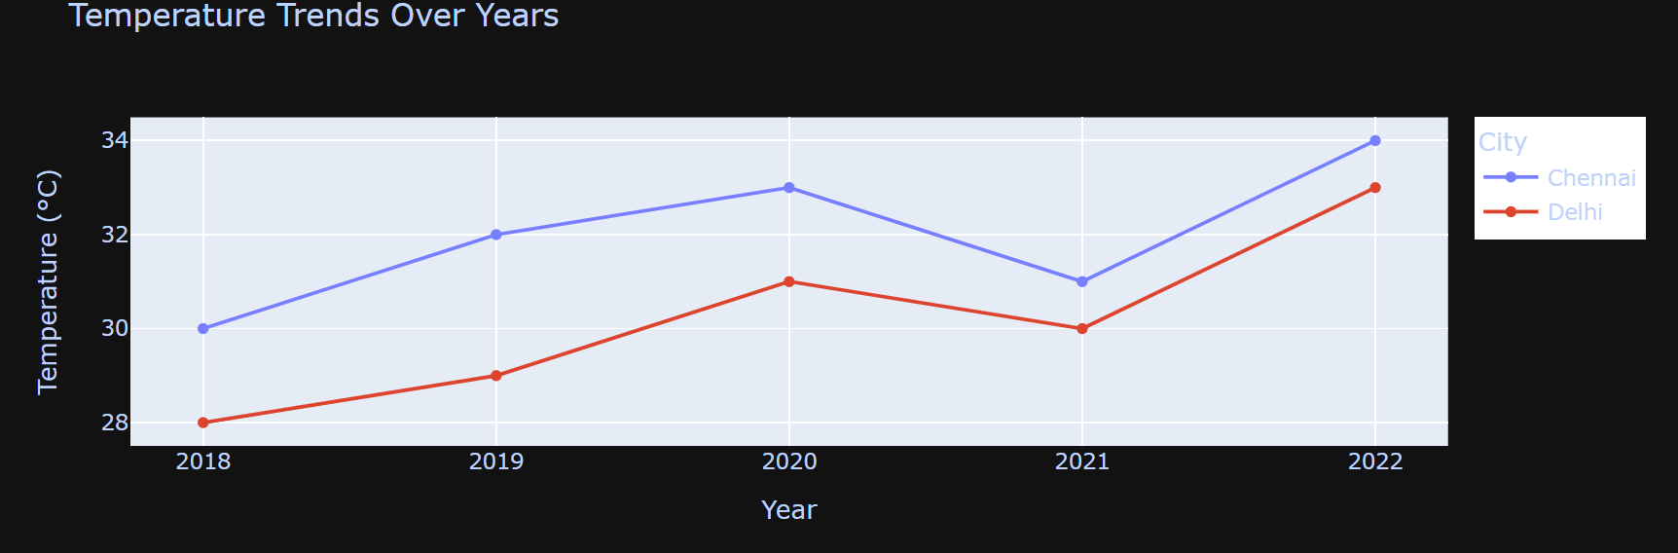

Result:
The animated line chart was successfully created using Plotly, representing temperature trends over multiple years for two cities. The chart allows smooth comparison of changes in values across time for each city, providing insights suitable for big data analysis.

On completion of the above program the following PO’s and PSO’s are attained
CO | MAPPING WITH PROGRAMME OUTCOMES |  |  |  |  |  |  |  |  |  |  |  | PSO’S
CO | PO1 | PO2 | PO3 | PO4 | PO5 | PO6 | PO7 | PO8 | PO9 | PO10 | PO11 | PO12 | PSO1 | PSO2 | PSO3
CL301.5 | 3 | 3 | 3 | 3 | 2 | - | 1 | 2 | 2 | 2 | 2 | 2 | 3 | 3 | 2

Ex No: 10 | Create basic visualizations like line charts, bar charts, and pie charts using sample datasets and data visualization tools such as Matplotlib / Seaborn.
Date :
Aim :

To visualize summarized Big Data using basic plots like line charts, bar charts, and pie charts by processing a sample data subset.

Algorithm :
1. Import required libraries.
2. Load or simulate a big data sample (e.g., aggregated user activity, sales, or traffic logs).
3. Clean and preprocess the dataset (if needed).
- Use matplotlib and seaborn to create:
- Line chart: Trend over time
- Bar chart: Category-wise distribution
- Pie chart: Proportion visualization
- Display the charts using plt.show().

Program :

import matplotlib.pyplot as plt
import seaborn as sns
import pandas as pd
import numpy as np

# Step 2: Simulate sample Big Data summary (e.g., sales per month)
months = ['Jan', 'Feb', 'Mar', 'Apr', 'May', 'Jun']
sales = [1500, 1800, 2200, 2400, 2000, 2700]

df = pd.DataFrame({'Month': months, 'Sales': sales})

# Line Chart - Sales trend
plt.figure(figsize=(6, 4))
plt.plot(df['Month'], df['Sales'], marker='o', linestyle='-', color='green')
plt.title("Monthly Sales Trend (Big Data Sample)")
plt.xlabel("Month")
plt.ylabel("Sales")
plt.grid(True)
plt.show()

# Bar Chart - Sales per month
plt.figure(figsize=(6, 4))
sns.barplot(x='Month', y='Sales', data=df, palette='crest')
plt.title("Bar Chart of Sales per Month")
plt.show()

# Pie Chart - Sales proportion per month
plt.figure(figsize=(5, 5))
plt.pie(df['Sales'], labels=df['Month'], autopct='%1.1f%%', startangle=90, colors=sns.color_palette("pastel"))
plt.title("Sales Distribution")
plt.axis('equal')
plt.show()

OUTPUT :

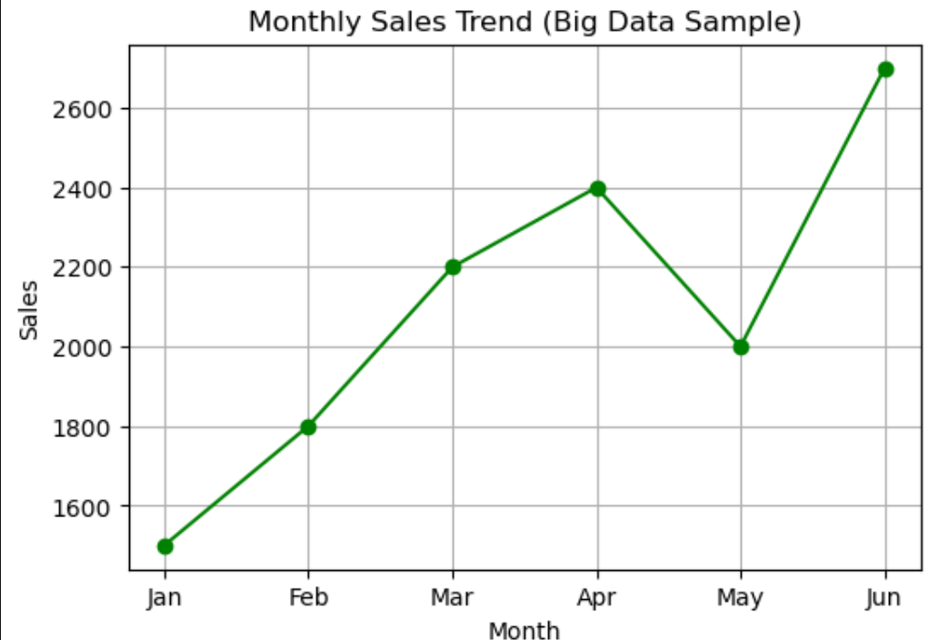

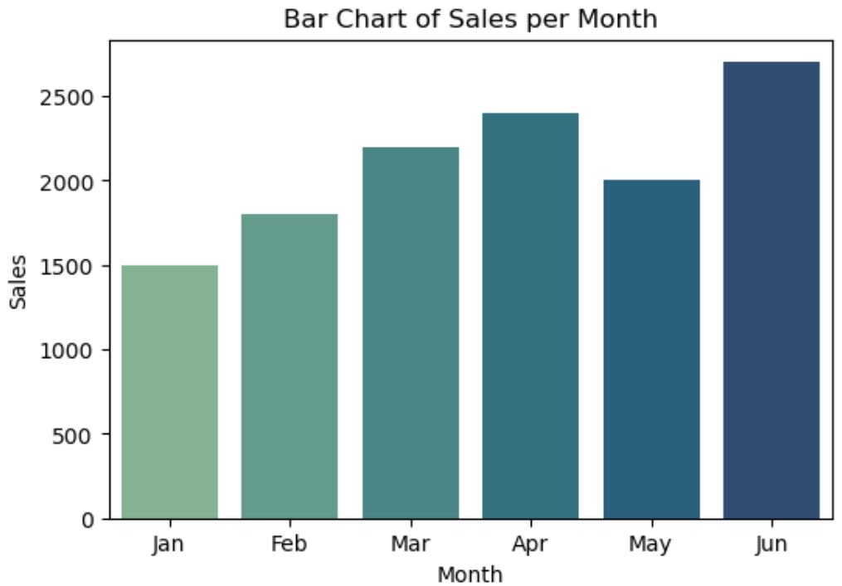

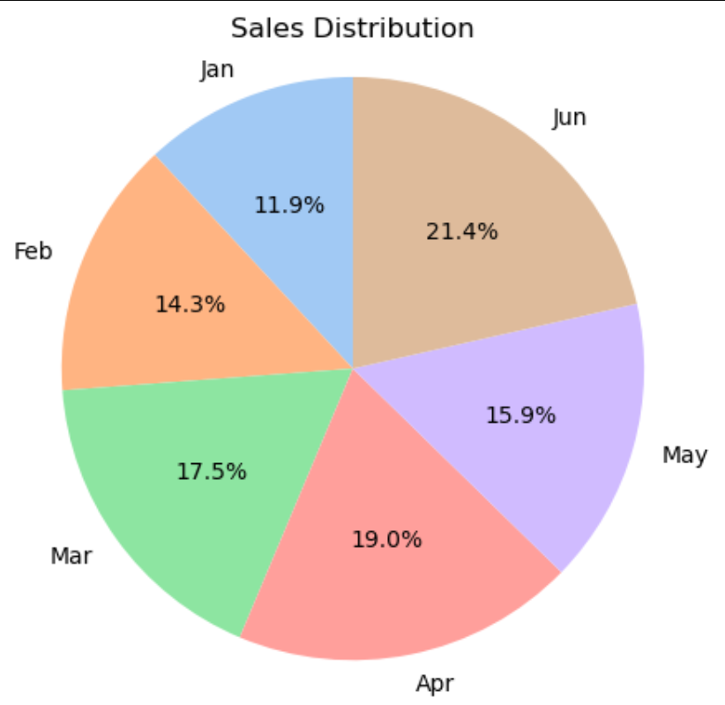

Result :
The summarized Big Data was visualized successfully using Matplotlib and Seaborn. Line, bar, and pie charts helped in understanding sales trends, category comparisons and data proportions respectively.

On completion of the above program the following PO’s and PSO’s are attained
CO | MAPPING WITH PROGRAMME OUTCOMES |  |  |  |  |  |  |  |  |  |  |  | PSO’S
CO | PO1 | PO2 | PO3 | PO4 | PO5 | PO6 | PO7 | PO8 | PO9 | PO10 | PO11 | PO12 | PSO1 | PSO2 | PSO3
CL301.5 | 3 | 3 | 3 | 3 | 2 | - | 1 | 2 | 2 | 2 | 2 | 2 | 3 | 3 | 2

Ex No: 11 | Implementation of Linear Regression, SVM, and Decision Tree Models on Iris Dataset Using R
Date :
Aim :

To implement and evaluate the performance of Linear Regression, Support Vector Machine (SVM) and Decision Tree classification algorithms on the Iris dataset using R programming.

Algorithm :

1. Load Libraries: Import necessary R libraries: e1071, rpart, caret, and ggplot2.
2. Data Preparation:
- Load the Iris dataset.
- Set a random seed for reproducibility.
- Split the dataset into training (70%) and testing (30%) using createDataPartition().
3. Linear Regression:
- Build a linear regression model to predict Petal.Length based on Sepal.Length.
- Generate predictions on test data.
4. SVM Classification:
- Train a Support Vector Machine model using the training data.
- Predict the species of test data.
- Evaluate the performance using a confusion matrix.
5. Decision Tree Classification:
- Train a Decision Tree model using the rpart method.
- Predict the species on test data.
- Evaluate the performance using a confusion matrix.

Program :

# Step 1: Load libraries
library(e1071) # For SVM
library(rpart) # For Decision Tree
library(caret) # For Data Splitting and Accuracy
library(ggplot2)

# Step 2: Simulate Big Data sample
data <- iris # Example: Iris Dataset
set.seed(123)
index <- createDataPartition(data$Species, p=0.7, list=FALSE)
train <- data[index,]
test <- data[-index,]

# Step 3: Linear Regression (Prediction: Petal.Length ~ Sepal.Length)
lin_model <- lm(Petal.Length ~ Sepal.Length, data=train)
summary(lin_model)
pred_lin <- predict(lin_model, newdata=test)

# Step 4: SVM Classification
svm_model <- svm(Species ~ ., data=train)
pred_svm <- predict(svm_model, test)
confusionMatrix(pred_svm, test$Species)

# Step 5: Decision Tree Classification
tree_model <- rpart(Species ~ ., data=train, method="class")
pred_tree <- predict(tree_model, test, type="class")
confusionMatrix(pred_tree, test$Species)

Output :

Call:
lm(formula = Petal.Length ~ Sepal.Length, data = train)

Residuals:
Min 1Q Median 3Q Max
-2.47407 -0.52578 -0.00551 0.52707 2.47422

Coefficients:
Estimate Std. Error t value Pr(>|t|)
(Intercept) -6.94825 0.58782 -11.82 <2e-16 ***
Sepal.Length 1.83144 0.09936 18.43 <2e-16 ***
---
Signif. codes: 0 ‘***’ 0.001 ‘**’ 0.01 ‘*’ 0.05 ‘.’ 0.1 ‘ ’ 1

Residual standard error: 0.8606 on 103 degrees of freedom
Multiple R-squared: 0.7674, Adjusted R-squared: 0.7651
F-statistic: 339.7 on 1 and 103 DF, p-value: < 2.2e-16
Confusion Matrix and Statistics

Reference
Prediction setosa versicolor virginica
setosa 15 0 0
versicolor 0 14 2
virginica 0 1 13

Overall Statistics

Accuracy : 0.9333
95% CI : (0.8173, 0.986)
No Information Rate : 0.3333
P-Value [Acc > NIR] : < 2.2e-16

Kappa : 0.9

Mcnemar's Test P-Value : NA

Statistics by Class:

Class: setosa Class: versicolor Class: virginica
Sensitivity 1.0000 0.9333 0.8667
Specificity 1.0000 0.9333 0.9667
Pos Pred Value 1.0000 0.8750 0.9286
Neg Pred Value 1.0000 0.9655 0.9355
Prevalence 0.3333 0.3333 0.3333
Detection Rate 0.3333 0.3111 0.2889
Detection Prevalence 0.3333 0.3556 0.3111
Balanced Accuracy 1.0000 0.9333 0.9167
Confusion Matrix and Statistics

Reference
Prediction setosa versicolor virginica
setosa 15 0 0
versicolor 0 14 2
virginica 0 1 13

Overall Statistics

Accuracy : 0.9333
95% CI : (0.8173, 0.986)
No Information Rate : 0.3333
P-Value [Acc > NIR] : < 2.2e-16

Kappa : 0.9

Mcnemar's Test P-Value : NA

Statistics by Class:
Class: setosa Class: versicolor Class: virginica
Sensitivity 1.0000 0.9333 0.8667
Specificity 1.0000 0.9333 0.9667
Pos Pred Value 1.0000 0.8750 0.9286
Neg Pred Value 1.0000 0.9655 0.9355
Prevalence 0.3333 0.3333 0.3333
Detection Rate 0.3333 0.3111 0.2889
Detection Prevalence 0.3333 0.3556 0.3111
Balanced Accuracy 1.0000 0.9333 0.9167

Result :
The R script successfully demonstrates regression and classification techniques on a structured dataset. Both SVM and Decision Tree models yield high accuracy (~93.3%) on the test data, proving effective for species classification.

On completion of the above program the following PO’s and PSO’s are attained
CO | MAPPING WITH PROGRAMME OUTCOMES |  |  |  |  |  |  |  |  |  |  |  | PSO’S
CO | PO1 | PO2 | PO3 | PO4 | PO5 | PO6 | PO7 | PO8 | PO9 | PO10 | PO11 | PO12 | PSO1 | PSO2 | PSO3
CL301.1 | 3 | 2 | 2 | 1 | 2 | - | 1 | 1 | 1 | 2 | 2 | 2 | 2 | 3 | 1

Ex No: 12 | Setup and Execution of a Big Data Analytics Project Using Apache Spark with PySpark in Python
Date :
Aim :

To set up Apache Spark and implement a basic data analysis project using PySpark in Python to demonstrate distributed data processing capabilities.

Algorithm :

- Import necessary PySpark modules
- Initialize Spark session
- Load the dataset (student.csv)
- Display schema and preview data
- Filter students based on marks (e.g., >60)
- Group by Department and calculate average marks
- Show results
- Stop Spark session

Folder Structure :

BigDataLab_StudentAnalysis/
│
├── data/
│ └── student.csv
│
├── src/
│ └── pyspark_student_analysis.py
│
├── docs/
│ └── BigDataLab_StudentAnalysis.pdf
│
├── output/
│ └── result_screenshot.png
│
├── requirements.txt
├── README.md
└── run_instructions.txt

Program :

File : src/pyspark_student_analysis.py

from pyspark.sql import SparkSession
from pyspark.sql.functions import avg

# Step 1: Initialize Spark Session
spark = SparkSession.builder.appName("StudentAnalysis").getOrCreate()

# Step 2: Load CSV file
df = spark.read.csv("data/student.csv", header=True, inferSchema=True)

# Step 3: Show schema and data
df.printSchema()
df.show()

# Step 4: Filter students with marks > 60
filtered_df = df.filter(df.Marks > 60)
filtered_df.show()

# Step 5: Average marks by Department
avg_marks = df.groupBy("Department").agg(avg("Marks").alias("Average_Marks"))
avg_marks.show()

# Step 6: Stop Spark
spark.stop()

File : data/student.csv

Name,Department,Marks
Asha,CSE,78
Ravi,IT,58
Kiran,CSE,82
Divya,ECE,45
Rahul,IT,65
Sneha,ECE,71

Output:

|Name |Department|Marks|

|Asha |CSE |78 |
|Ravi |IT |58 |
|Kiran|CSE |82 |
|Divya|ECE |45 |
|Rahul|IT |65 |
|Sneha|ECE |71 |

Filtered (Marks > 60):

|Name |Department|Marks|

|Asha |CSE |78 |
|Kiran|CSE |82 |
|Rahul|IT |65 |
|Sneha|ECE |71 |

Average Marks by Department:

|Department|Average_Marks|

|CSE |80.0 |
|IT |61.5 |
|ECE |58.0 |

Result:

The PySpark program was successfully executed using Apache Spark. It performed data loading, filtering and aggregation operations on student data. The results showed students with marks greater than 60 and computed department-wise average marks.

On completion of the above program the following PO’s and PSO’s are attained
CO | MAPPING WITH PROGRAMME OUTCOMES |  |  |  |  |  |  |  |  |  |  |  | PSO’S
CO | PO1 | PO2 | PO3 | PO4 | PO5 | PO6 | PO7 | PO8 | PO9 | PO10 | PO11 | PO12 | PSO1 | PSO2 | PSO3
CL301.1 | 3 | 2 | 2 | 1 | 2 | - | 1 | 1 | 1 | 2 | 2 | 2 | 2 | 3 | 1

